**Register Number – 21BPS1045**

**Name – SAJAL BRAHMA**

**AIM :** Design a LEX program to identify numbers , keyword ( more than 10 ) identifiers , header files , parenthesis.

**PROGRAM CODE -**

%{

#include<stdio.h>

#include<stdlib.h>

%}

DIGIT [0-9]

LETTER [a-zA-Z]

IDENTIFIER {LETTER}({LETTER}|{DIGIT})*

NUMBER {DIGIT}+(\.{DIGIT}+)?(E[+\-]?{DIGIT}+)?

WHITESPACE [ \t\n]

%%

{WHITESPACE} ; // Ignore whitespace

{IDENTIFIER} { printf("Identifier: %s\n", yytext); }

{NUMBER} { printf("Number: %s\n", yytext); }

"+" { printf("Operator: %s\n", yytext); }

"-" { printf("Operator: %s\n", yytext); }

"*" { printf("Operator: %s\n", yytext); }

"/" { printf("Operator: %s\n", yytext); }

"=" { printf("Operator: %s\n", yytext); }

"(" { printf("Left Parenthesis: %s\n", yytext); }

")" { printf("Right Parenthesis: %s\n", yytext); }

";" { printf("Semicolon: %s\n", yytext); }

. { printf("Unknown token: %s\n", yytext); }

%%

int main()

{

yylex();

return 0;

}

int yywrap()

{

return 1;

}

**OUTPUT -**

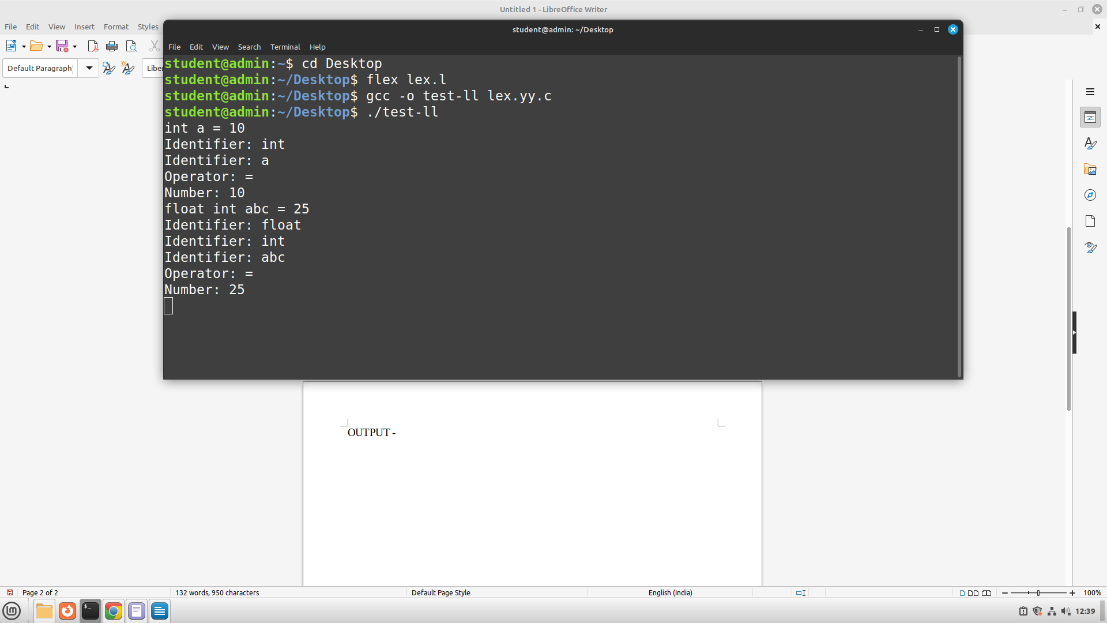**INFERENCE -**

The code is successfully implemented and verified in the lab.